

**DEPT. Of Computer Science Engineering**

**SRM IST, Kattankulathur – 603 203**

**TITLE OF THE PROJECT : HOSPITAL MANAGEMENT SYSTEM.**

NAME : S.Vikhram

Reg No: RA2111002010064

Department : MECHANICAL

Section : A

Submitted to : Dr. A Vijay Vasanth

**AIM :-**

To create a Hospital Management System using C programming.

**ABSTRACT : -**

A typical Hospital requires a management system to control it’s various operations such as maintaining account of all people in it’s domain of services, attending to various needs of patients and also achieving increased efficiency in the overall working of the Hospital itself. In the present time there is a great rush in hospitals, as these have become necessities for the middle and upper class of the society. Nowadays people are visiting the hospital because of this indecisive situation, even for a small issue we need to consult a doctor. The booking is manually done using paperwork and direct human language communication by mouth to the hospital management. This delays the information in the hospital. Booking is done through phone calls or through visits to the hospital or through online. The HOSPITAL MANAGEMENT SYSTEM aims to make simpler interaction between staff and patients. The system can be accessed by the admin and patients but the highest priority given to the admin is that they are allocated a login id and password. Hospital Management System provides various Appointments Booking Services, Managing the information of patients, Description regarding the Appointment booking. The proposed system enables automated data entry methods and enables fast and easy retrieval of guest records and data for fast reference activities.

**PROCEDURE :-**

**PROGRAM** :-

#include<stdio.h>

#include<windows.h>

#include<conio.h>

#include<string.h>

#include<stdlib.h>

char ans=0;

int ok;

int b, valid=0;

void WelcomeScreen(void);

void Title(void);

void MainMenu(void);

void LoginScreen(void);

void Add_rec(void);

void func_list();

void Search_rec(void);

void Edit_rec(void);

void Dlt_rec(void);

void ex_it(void);

void gotoxy(short x, short y) {

COORD pos = {x, y};

SetConsoleCursorPosition(GetStdHandle(STD_OUTPUT_HANDLE), pos);

}

struct patient

{

int age;

char Gender;

char First_Name[20];

char Last_Name[20];

char Contact_no[15];

char Address[30];

char Email[30];

char Doctor[20];

char Problem[20];

};

struct patient p,temp_c;

main(void)

{

WelcomeScreen();

Title();

LoginScreen();

}

/* ************************************************* Welcome Screen ********************************************* */

void WelcomeScreen(void)

{

printf("\n\n\n\n\n\n\n\t\t\t\t#########################################");

printf("\n\t\t\t\t# HOSPITAL MANAGEMENT SYSTEM #");

printf("\n\t\t\t\t#########################################");

printf("\n\n\n\n\n Press any key to continue......\n");

getch();

system("cls");

}

/* ************************************************* Title Screen ********************************************* */

void Title(void)

{

printf("\n\n\t\t----------------------------------------------------------------------------------");

printf("\n\t\t\t\t HOSPITAL SYSTEMS ");

printf("\n\t\t----------------------------------------------------------------------------------");

}

/* ************************************************* Main Menu ********************************************* */

void MainMenu(void)

{

system("cls");

int choose;

Title();

printf("\n\n\n\n\n\t\t\t\t1. Add Patients Record\n");

printf("\n\t\t\t\t2. List Patients Record\n");

printf("\n\t\t\t\t3. Search Patients Record\n");

printf("\n\t\t\t\t4. Edit Patients Record\n");

printf("\n\t\t\t\t5. Delete Patients Record\n");

printf("\n\t\t\t\t6. Exit\n");

printf("\n\n\n \n\t\t\t\tChoose from 1 to 6:");

scanf("%i", &choose);

switch(choose)

{

case 1:

Add_rec();

break;

case 2:

func_list();

break;

case 3:

Search_rec();

break;

case 4:

Edit_rec();

break;

case 5:

Dlt_rec();

break;

case 6:

ex_it();

break;

default:

printf("\t\t\tInvalid entry. Please enter right option :)");

getch();

}

}

/* ************************************************* Exit Screen ********************************************* */

void ex_it(void)

{

system("cls");

Title();

printf("\n\n\n\n\n\t\t\tTHANK YOU FOR VISITING :)");

getch();

}

/* ************************************************* Login Screen ********************************************* */

void LoginScreen(void)

{

int e=0 ;

char Username[15];

char Password[15];

char original_Username[25]="EMPLOYEE";

char original_Password[15]="plsopen";

do

{

printf("\n\n\n\n\t\t\t\tEnter your Username and Password :)");

printf("\n\n\n\t\t\t\t\tUSERNAME:");

scanf("%s",&Username);

printf("\n\n\t\t\t\t\tPASSWORD:");

scanf("%s",&Password);

if (strcmp(Username,original_Username)==0 && strcmp(Password,original_Password)==0)

{

printf("\n\n\n\t\t\t\t\t...Login Successfull...");

getch();

MainMenu();

break;

}

else

{

printf("\n\t\t\tPassword in incorrect:( Try Again :)");

e++;

getch();

}

}

while(e<=2);

if(e>2)

{

printf("You have cross the limit. You cannot login. :( :(");

getch();

ex_it();

}

system("cls");

}

/* **************************************ADD RECORD*******************************************/

void Add_rec(void)

{

system("cls");

Title();

char ans;

FILE*ek;

ek=fopen("Record2.dat","a");

printf("\n\n\t\t\t!!!!!!!!!!!!!! Add Patients Record !!!!!!!!!!!!!\n");

//first name

A:

printf("\n\t\t\tFirst Name: ");

scanf("%s",p.First_Name);

p.First_Name[0]=toupper(p.First_Name[0]);

if(strlen(p.First_Name)>20||strlen(p.First_Name)<2)

{

printf("\n\t Invalid :( \t The max range for first name is 20 and min range is 2 :)");

goto A;

}

else

{

for (b=0;b<strlen(p.First_Name);b++)

{

if (isalpha(p.First_Name[b]))

{

valid=1;

}

else

{

valid=0;

break;

}

}

if(!valid)

{

printf("\n\t\t First name contain Invalid character :( Enter again :)");

goto A;

}

}

//last name

B:

printf("\n\t\t\tLast Name: ");

scanf("%s",p.Last_Name);

p.Last_Name[0]=toupper(p.Last_Name[0]);

if(strlen(p.Last_Name)>20||strlen(p.Last_Name)<2)

{

printf("\n\t Invalid :( \t The max range for last name is 20 and min range is 2 :)");

goto B;

}

else

{

for (b=0;b<strlen(p.Last_Name);b++)

{

if (isalpha(p.Last_Name[b]))

{

valid=1;

}

else

{

valid=0;

break;

}

}

if(!valid)

{

printf("\n\t\t Last name contain Invalid character :( Enter again :)");

goto B;

}

}

//gender

do

{

printf("\n\t\t\tGender[F/M]: ");

scanf(" %c",&p.Gender);

if(toupper(p.Gender)=='M'|| toupper(p.Gender)=='F')

{

ok =1;

}

else

{

ok =0;

}

if(!ok)

{

printf("\n\t\t Gender contain Invalid character :( Enter either F or M :)");

}

} while(!ok);

//age

printf("\n\t\t\tAge:");

scanf(" %i",&p.age);

//address

do

{

C:

printf("\n\t\t\tAddress: ");

scanf("%s",p.Address);

p.Address[0]=toupper(p.Address[0]);

if(strlen(p.Address)>20||strlen(p.Address)<4)

{

printf("\n\t Invalid :( \t The max range for address is 20 and min range is 4 :)");

goto C;

}

}while(!valid);

//Contact no

do

{

D:

printf("\n\t\t\tContact no: ");

scanf("%s",p.Contact_no);

if(strlen(p.Contact_no)>10||strlen(p.Contact_no)!=10)

{

printf("\n\t Sorry :( Invalid. Contact no. must contain 10 numbers. Enter again :)");

goto D;

}

else

{

for (b=0;b<strlen(p.Contact_no);b++)

{

if (!isalpha(p.Contact_no[b]))

{

valid=1;

}

else

{

valid=0;

break;

}

}

if(!valid)

{

printf("\n\t\t Contact no. contain Invalid character :( Enter again :)");

goto D;

}

}

}while(!valid);

//email

do

{

printf("\n\t\t\tEmail: ");

scanf("%s",p.Email);

if (strlen(p.Email)>30||strlen(p.Email)<8)

{

printf("\n\t Invalid :( \t The max range for email is 30 and min range is 8 :)");

}

}while(strlen(p.Email)>30||strlen(p.Email)<8);

//problem

E:

printf("\n\t\t\tProblem: ");

scanf("%s",p.Problem);

p.Problem[0]=toupper(p.Problem[0]);

if(strlen(p.Problem)>15||strlen(p.Problem)<3)

{

printf("\n\t Invalid :( \t The max range for first name is 15 and min range is 3 :)");

goto E;

}

else

{

for (b=0;b<strlen(p.Problem);b++)

{

if (isalpha(p.Problem[b]))

{

valid=1;

}

else

{

valid=0;

break;

}

}

if(!valid)

{

printf("\n\t\t Problem contain Invalid character :( Enter again :)");

goto E;

}

}

//doctor

F:

printf("\n\t\t\tPrescribed Doctor:");

scanf("%s",p.Doctor);

p.Doctor[0]=toupper(p.Doctor[0]);

if(strlen(p.Doctor)>30||strlen(p.Doctor)<3)

{

printf("\n\t Invalid :( \t The max range for first name is 30 and min range is 3 :)");

goto F;

}

else

{

for (b=0;b<strlen(p.Doctor);b++)

{

if (isalpha(p.Doctor[b]))

{

valid=1;

}

else

{

valid=0;

break;

}

}

if(!valid)

{

printf("\n\t\t Doctor name contain Invalid character :( Enter again :)");

goto F;

}

}

fprintf(ek," %s %s %c %i %s %s %s %s %s\n", p.First_Name, p.Last_Name, p.Gender, p.age, p.Address, p.Contact_no, p.Email, p.Problem, p.Doctor);

printf("\n\n\t\t\t.... Information Record Successful ...");

fclose(ek);

sd:

getch();

printf("\n\n\t\t\tDo you want to add more[Y/N]?? ");

scanf(" %c",&ans);

if (toupper(ans)=='Y')

{

Add_rec();

}

else if(toupper(ans)=='N')

{

printf("\n\t\t Thank you :) :)");

getch();

MainMenu();

}

else

{

printf("\n\t\tInvalid Input\n");

goto sd;

}

}

/* **************************************VIEW RECORD*******************************************/

void func_list()

{

int row;

system("cls");

Title();

FILE *ek;

ek=fopen("Record2.dat","r");

printf("\n\n\t\t\t!!!!!!!!!!!!!! List Patients Record !!!!!!!!!!!!!\n");

gotoxy(1,15);

printf("Full Name");

gotoxy(20,15);

printf("Gender");

gotoxy(32,15);

printf("Age");

gotoxy(37,15);

printf("Address");

gotoxy(49,15);

printf("Contact No.");

gotoxy(64,15);

printf("Email");

gotoxy(88,15);

printf("Problem");

gotoxy(98,15);

printf("Prescribed Doctor\n");

printf("=================================================================================================================");

row=17;

while(fscanf(ek,"%s %s %c %i %s %s %s %s %s\n", p.First_Name, p.Last_Name,

&p.Gender, &p.age, p.Address, p.Contact_no, p.Email, p.Problem, p.Doctor)!=EOF)

{

gotoxy(1,row);

printf("%s %s",p.First_Name, p.Last_Name);

gotoxy(20,row);

printf("%c",p.Gender);

gotoxy(32,row);

printf("%i",p.age);

gotoxy(37,row);

printf("%s",p.Address);

gotoxy(49,row);

printf("%s",p.Contact_no);

gotoxy(64,row);

printf("%s",p.Email);

gotoxy(88,row);

printf("%s",p.Problem);

gotoxy(98,row);

printf("%s",p.Doctor);

row++;

}

fclose(ek);

getch();

MainMenu();

}

void Search_rec(void)

{

char name[20];

system("cls");

Title();

FILE *ek;

ek=fopen("Record2.dat","r");

printf("\n\n\t\t\t!!!!!!!!!!!!!! Search Patients Record !!!!!!!!!!!!!\n");

gotoxy(12,8);

printf("\n Enter Patient Name to be viewed:");

scanf("%s",name);

fflush(stdin);

name[0]=toupper(name[0]);

while(fscanf(ek,"%s %s %c %i %s %s %s %s %s\n", p.First_Name, p.Last_Name, &p.Gender, &p.age, p.Address, p.Contact_no, p.Email, p.Problem, p.Doctor)!=EOF)

{

if(strcmp(p.First_Name,name)==0)

{

gotoxy(1,15);

printf("Full Name");

gotoxy(25,15);

printf("Gender");

gotoxy(32,15);

printf("Age");

gotoxy(37,15);

printf("Address");

gotoxy(52,15);

printf("Contact No.");

gotoxy(64,15);

printf("Email");

gotoxy(80,15);

printf("Problem");

gotoxy(95,15);

printf("Prescribed Doctor\n");

printf("=================================================================================================================");

gotoxy(1,18);

printf("%s %s",p.First_Name, p.Last_Name);

gotoxy(25,18);

printf("%c",p.Gender);

gotoxy(32,18);

printf("%i",p.age);

gotoxy(37,18);

printf("%s",p.Address);

gotoxy(52,18);

printf("%s",p.Contact_no);

gotoxy(64,18);

printf("%s",p.Email);

gotoxy(80,18);

printf("%s",p.Problem);

gotoxy(95,18);

printf("%s",p.Doctor);

printf("\n");

break;

}

}

if(strcmp(p.First_Name,name)!=0)

{

gotoxy(5,10);

printf("Record not found!");

getch();

}

fclose(ek);

L:

getch();

printf("\n\n\t\t\tDo you want to view more[Y/N]??");

scanf("%c",&ans);

if (toupper(ans)=='Y')

{

Search_rec();

}

else if(toupper(ans)=='N')

{

printf("\n\t\t Thank you :) :)");

getch();

MainMenu();

}

else

{

printf("\n\tInvalid Input.\n");

goto L;

}

}

void Edit_rec(void)

{

FILE *ek, *ft;

int i,b, valid=0;

char ch;

char name[20];

system("cls");

Title();

ft=fopen("temp2.dat","w+");

ek=fopen("Record2.dat","r");

if(ek==NULL)

{

printf("\n\t Can not open file!! ");

getch();

MainMenu();

}

printf("\n\n\t\t\t!!!!!!!!!!!!!! Edit Patients Record !!!!!!!!!!!!!\n");

gotoxy(12,13);

printf("Enter the First Name of the Patient : ");

scanf(" %s",name);

fflush(stdin);

name[0]=toupper(name[0]);

gotoxy(12,15);

if(ft==NULL)

{

printf("\n Can not open file");

getch();

MainMenu();

}

while(fscanf(ek,"%s %s %c %i %s %s %s %s %s\n", p.First_Name, p.Last_Name, &p.Gender, &p.age, p.Address, p.Contact_no, p.Email, p.Problem, p.Doctor)!=EOF)

{

if(strcmp(p.First_Name, name)==0)

{

valid=1;

gotoxy(25,17);

printf("*** Existing Record ***");

gotoxy(10,19);

printf("%s \t%s \t%c \t%i \t%s \t%s \t%s \t%s \t%s\n",p.First_Name,p.Last_Name,p.Gender, p.age,p.Address,p.Contact_no,p.Email,p.Problem,p.Doctor);

gotoxy(12,22);

printf("Enter New First Name: ");

scanf("%s",p.First_Name);

gotoxy(12,24);

printf("Enter Last Name: ");

scanf("%s",p.Last_Name);

gotoxy(12,26);

printf("Enter Gender: ");

scanf(" %c",&p.Gender);

p.Gender=toupper(p.Gender);

gotoxy(12,28);

printf("Enter age: ");

scanf(" %i",&p.age);

gotoxy(12,30);

printf("Enter Address: ");

scanf("%s",p.Address);

p.Address[0]=toupper(p.Address[0]);

gotoxy(12,32);

printf("Enter Contact no: ");

scanf("%s",p.Contact_no);

gotoxy(12,34);

printf("Enter New email: ");

scanf("%s",p.Email);

gotoxy(12,36);

printf("Enter Problem: ");

scanf("%s",p.Problem);

p.Problem[0]=toupper(p.Problem[0]);

gotoxy(12,38);

printf("Enter Doctor: ");

scanf("%s",p.Doctor);

p.Doctor[0]=toupper(p.Doctor[0]);

printf("\nPress U charecter for the Updating operation : ");

ch=getche();

if(ch=='u' || ch=='U')

{

fprintf(ft,"%s %s %c %i %s %s %s %s %s\n",p.First_Name,p.Last_Name,p.Gender, p.age,p.Address,p.Contact_no,p.Email,p.Problem,p.Doctor);

printf("\n\n\t\t\tPatient record updated successfully...");

}

}

else

{

fprintf(ft,"%s %s %c %i %s %s %s %s %s\n",p.First_Name,p.Last_Name,p.Gender, p.age,p.Address,p.Contact_no,p.Email,p.Problem,p.Doctor);

}

}

if(!valid) printf("\n\t\tNO RECORD FOUND...");

fclose(ft);

fclose(ek);

remove("Record2.dat");

rename("temp2.dat","Record2.dat");

getch();

MainMenu();

}

void Dlt_rec()

{

char name[20];

int found=0;

system("cls");

Title();

FILE *ek, *ft;

ft=fopen("temp_file2.dat","w+");

ek=fopen("Record2.dat","r");

printf("\n\n\t\t\t!!!!!!!!!!!!!! Delete Patients Record !!!!!!!!!!!!!\n");

gotoxy(12,8);

printf("\n Enter Patient Name to delete: ");

fflush(stdin);

gets(name);

name[0]=toupper(name[0]);

while (fscanf(ek,"%s %s %c %i %s %s %s %s %s", p.First_Name, p.Last_Name, &p.Gender,

&p.age, p.Address, p.Contact_no, p.Email, p.Problem, p.Doctor)!=EOF)

{

if (strcmp(p.First_Name,name)!=0)

fprintf(ft,"%s %s %c %i %s %s %s %s %s\n", p.First_Name, p.Last_Name, p.Gender, p.age, p.Address, p.Contact_no, p.Email, p.Problem, p.Doctor);

else

{

printf("%s %s %c %i %s %s %s %s %s\n", p.First_Name, p.Last_Name, p.Gender, p.age, p.Address, p.Contact_no, p.Email, p.Problem, p.Doctor);

found=1;

}

}

if(found==0)

{

printf("\n\n\t\t\t Record not found....");

getch();

MainMenu();

}

else

{

fclose(ek);

fclose(ft);

remove("Record2.dat");

rename("temp_file2.dat","Record2.dat");

printf("\n\n\t\t\t Record deleted successfully :) ");

getch();

MainMenu();

}

}

**SAMPLE INPUT AND OUTPUT :-**

Options:

1. 1Add patients records
2. List patients records
3. Search patients records
4. Edit patients records
5. Delete patients records
6. Exit

Choose from 1 to 6: 1

First Name: Arul

Last Name: Boomesh

Gender[F/M]: M

Age: 26

Address: Flat No.11, Azerbain Colony, Chennai 600 009

Contact No: 95812 73746

EMail: [boomesh20@gmail.com](mailto:boomesh20@gmail.com)

Problem: Typhoid

Prescribed Doctor: Sunder

*Patients detailed added successfully*

1. Add patients records

2. List patients records

3.Search patients records

4.Edit patients records

5.Delete patients records

6.Exit

Option:2

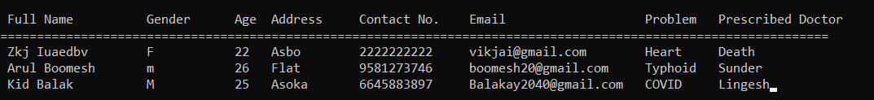

1. Add patients record

2. List patients records

3.Search patients records

4.Edit patients records

5.Delete patients records

6.Exit

Option: 3

Enter patient name to be viewed: Arul Boomesh

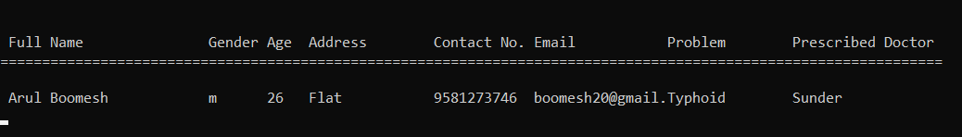

1. Add patients record

2. List patients records

3.Search patients records

4.Edit patients records

5.Delete patients records

6.Exit

Option: 4

Enter the first name of the patient: Arul

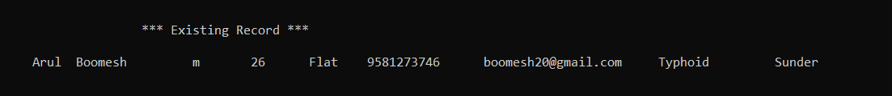

Enter new first name: Arul

Enter last name: Boomesh

Enter gender: M

Enter Age: 29 (change made here)

Address: Flat No.11, Azerbain Colony, Chennai 600 009

Contact No: 95812 73746

EMail: [boomesh20@gmail.com](mailto:boomesh20@gmail.com)

Problem: Typhoid

Prescribed Doctor: Sunder

*patient record updated successfully*

1. Add patients record

2. List patients records

3.Search patients records

4.Edit patients records

5.Delete patients records

6.Exit

Option: 5

Enter patient name to delete: Kid Balak

*patient record deleted*

Option: 6

THANK YOU FOR VISITING

*program closes*

SAMPLE INPUT AND OUTPUT:

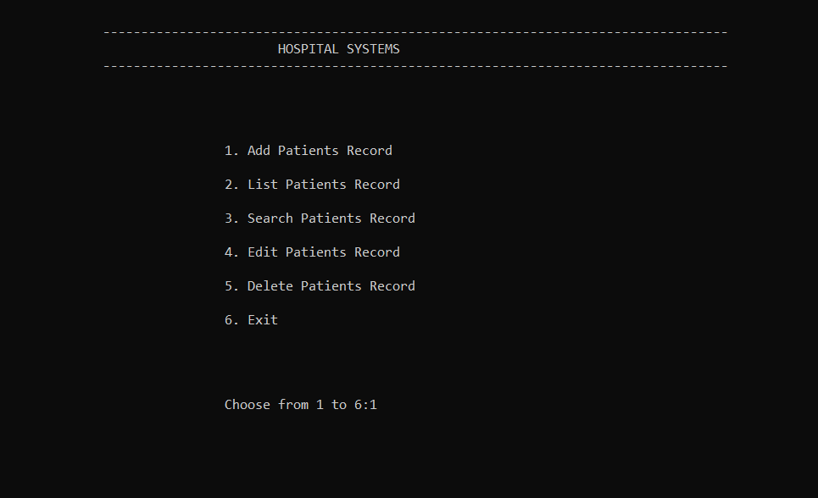

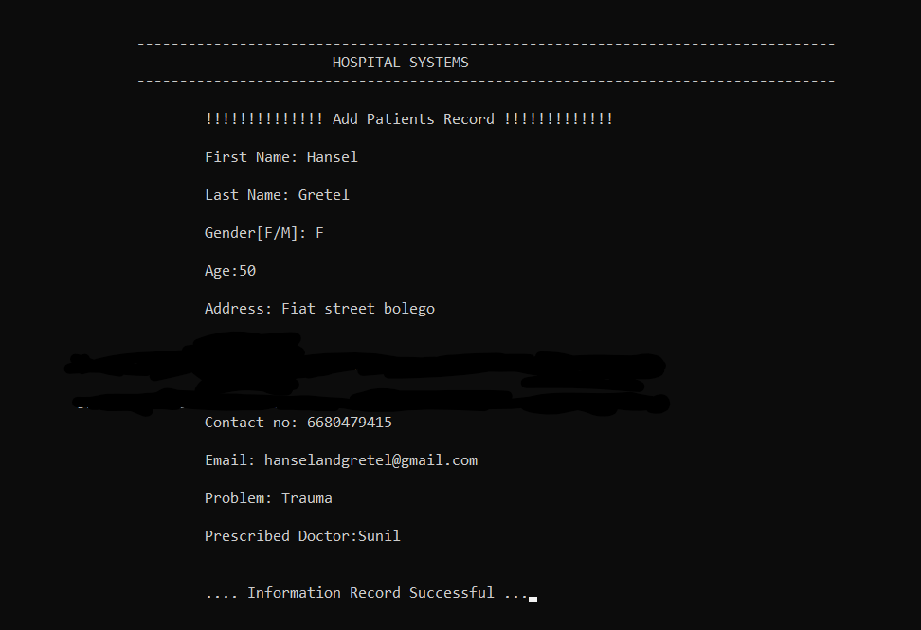

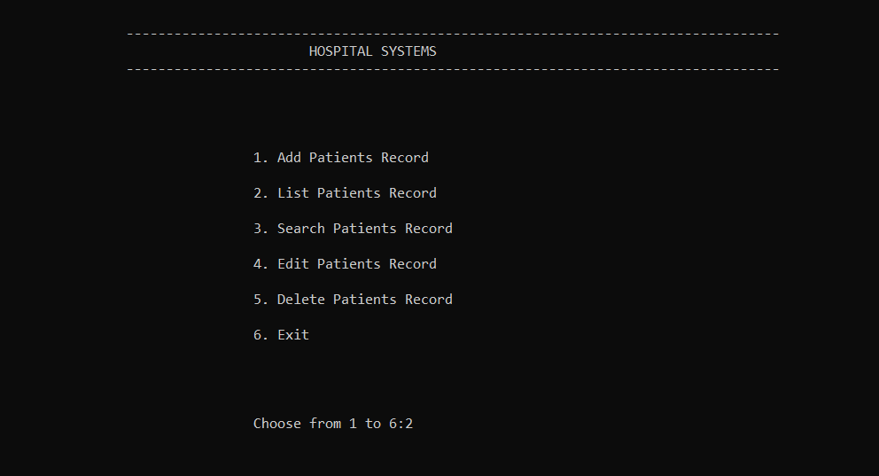

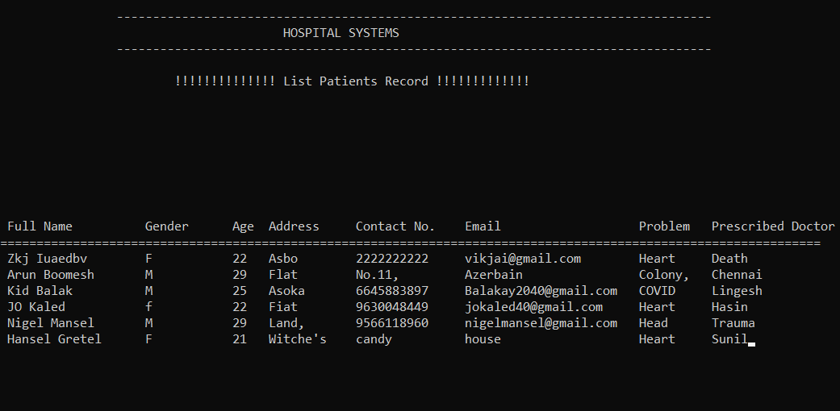

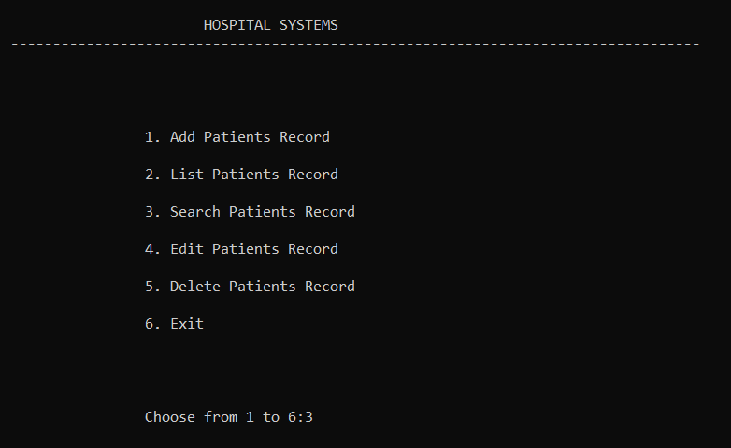

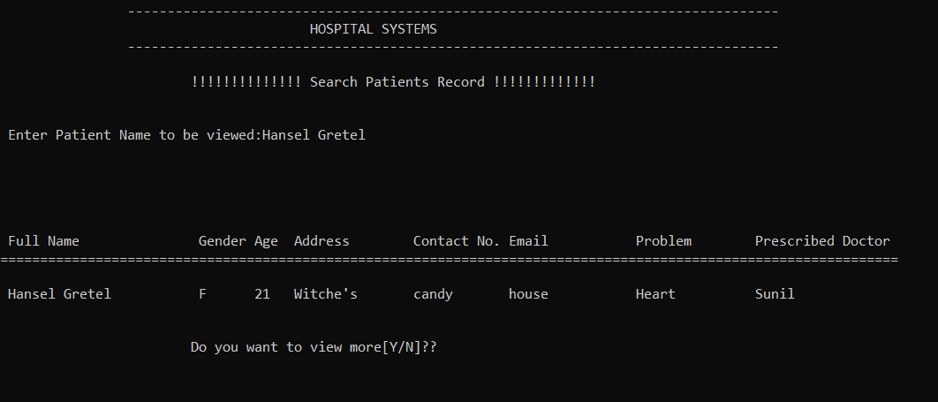

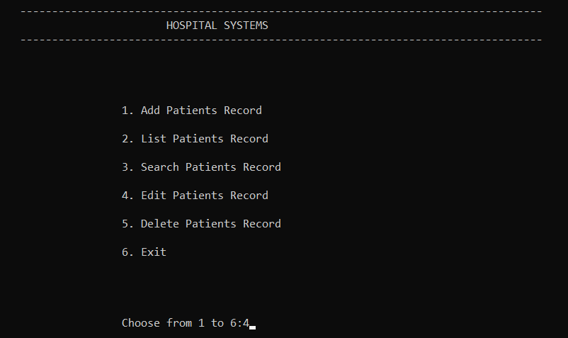

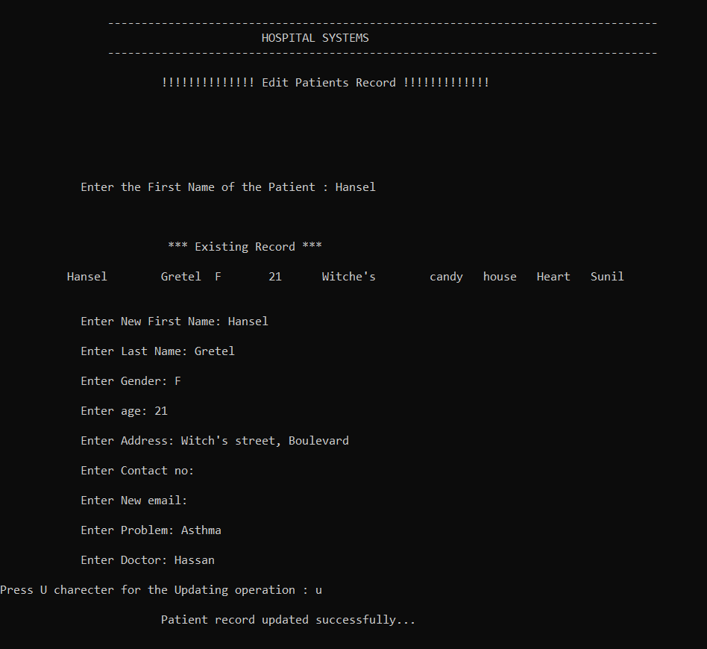

**DECLARATION :**

I hereby declare that the project entitled “HOSPITAL MANAGEMENT SYSTEM'' was submitted by Vikhram Sundararaghavan to SRM Institute of Science and Technology.

I would like to thank our faculty Dr. A Vijay Vasanth for the guidance throughout the process of making this project .